**Name: Shaista**

**Registration: 41488**

**Sub Use Cases**

**Sub Use Case 1:**

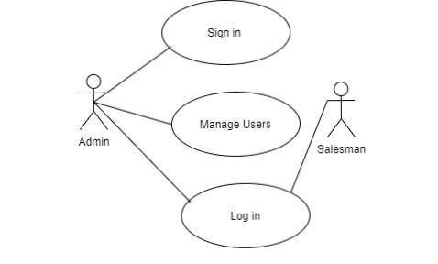

|  |  |
| --- | --- |
| **Use Case Name** | Log in to the inventory system |
| **Actors Involved** | Admin and Salesman |
| **Brief Description** | Admin needs to sign in into the system. The admin can manage users and can grant access to any user. |
| **Flow of Events** | |  |  | | --- | --- | | **Actor Action** | **System Response** | | 1. Enter email address and password. | 1. System displays the actor (Admin) main page on successful login. | | 2. Clicks the submit button. | 2. System displays error message on invalid login. | | 1. Admin can manage users by giving access into the system. | 1. The Salesman can now login to the system by entering login credentials. | |

**Sub Use Case 2:**

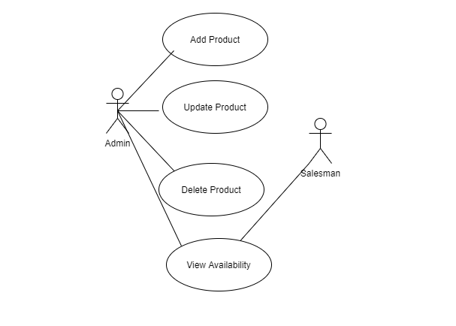

|  |  |
| --- | --- |
| **Use Case Name** | Updating Products |
| **Actors Involved** | Admin and Salesman |
| **Brief Discussion** | The Admin can manage products (add, update, delete). Both the actors can check product availability in the inventory in order to maintain and check the stock available or short in quantity. |
| **Flow Of Events** | |  |  | | --- | --- | | **Actor Action** | **System Response** | | 1. After logging into the system, the admin adds the product details, and clicks add button. | 1. The products successfully added into the system. | | 1. Clicks the update button if required. | 1. The item has been updated. | | 1. Clicks delete button if required. | 1. The item has been deleted. | | 1. Searching for products. | 4. Checking stock and quantity of products. | |

**Sub Use Case 3:**

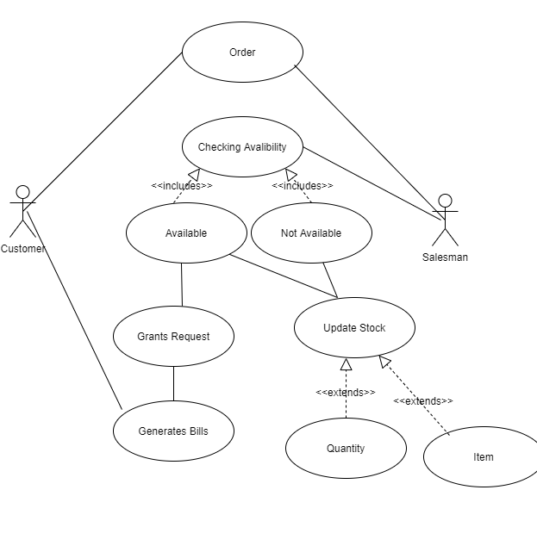

|  |  |
| --- | --- |
| **Use Case Name** | Managing Orders and updating Stock |
| **Actors Involve** | Customer and Salesman |
| **Brief Description** | When an order is arrived, the salesman will check the availability of the required product and if available will fulfill the request and generates a bill. In case of both available or not, the system will be updated and will notify on the current state of the stock. |
| **Flow Of Events** | |  |  | | --- | --- | | **Actors Action** | **System Response** | | 1. The search option will help finding required product on customer request by name. | 1. Search option will show the required results. | | 1. After fulfilment of request, clicking generate bill option. | 2. The system will generate bill. | |

**Sub Use Case 4:**

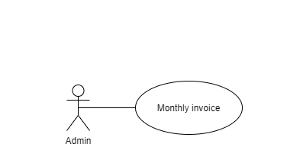

|  |  |
| --- | --- |
| **Use Case Name** | Generating Reports |
| **Actors Involved** | Admin |
| **Brief Description** | Admin can generate monthly inventory records. |
| **Flow Of Events** | |  |  | | --- | --- | | **Actors Action** | **System Response** | | 1. Clicks the generate report button | 1. The system will generate monthly report. | |